Supporting Information

Effective Visible Light-Activated N/Sn-TiO₂/In₂O₃ with Enhanced Photocatalytic Activity

1. Experimental Section
1.1. Catalyst Preparation. All chemicals used were of analytical grade and water was deionized water (18.2 MΩ⋅cm). Some InCl₃·4H₂O was added into water to form InCl₃ water solution which concentration was 0.6mol/L. The tri-doped catalysts were obtained by the following method. At room temperature, a certain volume of InCl₃ solution was mixed with 40 mL of ethanol to prepare solution A. After homogenous mixing, 12 ml Ti(OC₄H₉)₄ was added dropwise to solution A under vigorous stirring. And then 0.2 mL SnCl₄ and 3 mL ammonia were added in turn every 15 minutes with the continuously stirring. With addition of the ammonia, white precipitation was formed immediately. After aging at room temperature for 24 h, the as-prepared TiO₂ precipitation was dried at 100℃, and then triturated to powder in an agate mortar. And then the powder was calcined at 450℃ for 2.5 h in a muffle. Pure TiO₂, indium doped TiO₂ (In-TiO₂) tin doped TiO₂ (Sn-TiO₂) and nitrogen doped TiO₂ (N-TiO₂) were prepared by the same procedure but no corresponding dopants.

1.2. Characterization. The XRD patterns were acquired on a Rigaku D/max 2500 X-ray diffraction spectrometer (Cu Kα, λ=1.54056 Å). The average crystallite size was calculated according to the Scherrer formula (D = k λ/B cosθ). The BET surface areas of the samples were determined by nitrogen adsorption-desorption isotherm measurement at 77 K (Micromeritics Automatic Surface Area Analyzer Gemini 2360, Shimadzu). XPS measurements were carried out with an SECA Lab 220i-XL spectrometer by using an unmonochromated Al Kα (1486.6-eV) X-ray source. All the spectra were calibrated to the binding energy of the adventitious C1s peak at 284.6 eV. Raman spectra were taken on a Bruker RFS 100/S Raman spectrometer by using the 1064-nm line of a Nd:YAG laser as the excitation source. The diffuse reflectance UV-visible absorption spectra were collected on a UV-visible spectrometer (U-4100, Hitachi).
1.3 Evaluation of Photocatalytic Activity. The photocatalytic degradation of 4-chlorophenol was carried out in a 70 mL glass reactor with 10 mg amounts of catalysts suspended in 4-chlorophenol solution (5×10⁻⁵mol L⁻¹, 40 mL, pH = 5.74) under the visible light irradiation. A sunlamp (Philips HPA 400/30S, Belgium) was as light source, and a 400-nm filter was employed to remove ultraviolet light for obtainment of visible light. The reactor was perpendicular to the light beam and located 10 cm away from the light source. The 4-chlorophenol solution was continuously bubbled by O₂ gas at a flux of 5 mL min⁻¹ under magnetic stirring at 25±2 °C. Each two hours the residual concentration of 4-chlorophenol was measured by a UV-visible spectrometer (UV-1061PC, SHIMADZU) by using 4-aminoantipyrine as the chromogenic reagent. Prior to photocatalytic reactions, the suspension was magnetically stirred in the dark for 30 min, which was enough to reach the adsorption equilibrium of 4-chlorophenol.

2. Experimental Results
Table S1 The phases, crystallite sizes and surface areas of pure TiO₂ and doped TiO₂ samples.
sample | cell parameters (Å) |  | cell volume  (Å³) | crystallite size(nm) | S_{BET}  (m² g⁻¹)
sample | a =b | c | cell volume  (Å³) | crystallite size(nm) | S_{BET}  (m² g⁻¹)
TiO₂ | 3.784 | 9.501 | 136.03 | 12 | 68
N-TiO₂ | 3.786 | 9.497 | 136.16 | 12 | 76
Sn-TiO₂ | 3.794 | 9.487 | 136.57 | 8 | 112
In-TiO₂ | 3.785 | 9.489 | 135.97 | 9 | 82
N/Sn-TiO₂/In₂O₃ | 3.795 | 9.508 | 136.97 | 9 | 114
a calculated by Sherrer equation with anatase (101): D=0.89λ/βcosθ. λ=1.54055 nm, β=full width at half maximum value, θ = diffraction angle.

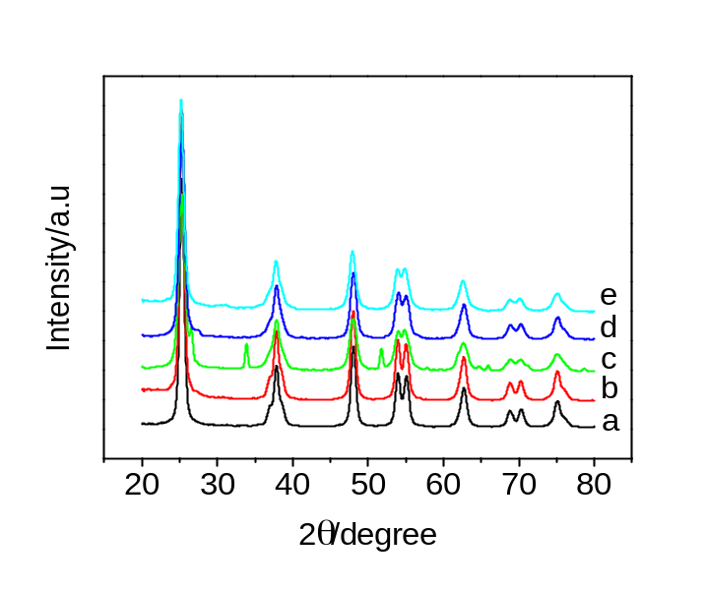
Figure S1 XRD patterns of (a) TiO₂, (b)N-TiO₂, (c)Sn-TiO₂, (d)In-TiO₂, (e)N/Sn-TiO₂/In₂O₃(0.5%).

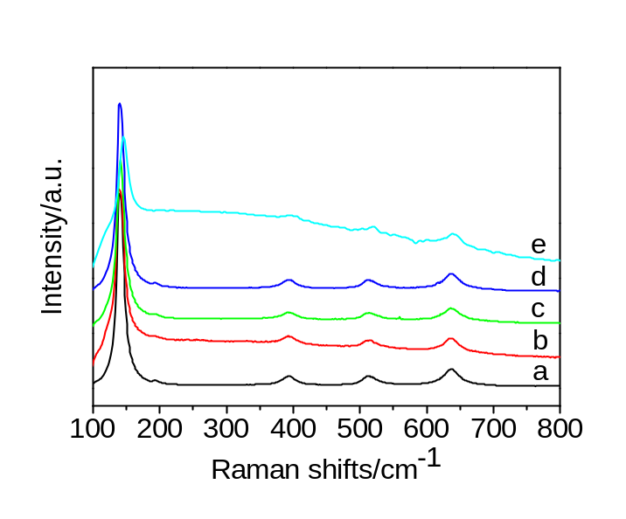
Figure S2 Raman spectra of (a) TiO₂, (b)N-TiO₂, (c)Sn-TiO₂, (d)In-TiO₂, (d)N/Sn-TiO₂/In₂O₃(0.3%), (e)N/Sn-TiO₂/In₂O₃(0.5%), (f)N/Sn-TiO₂/In₂O₃(1.0%)

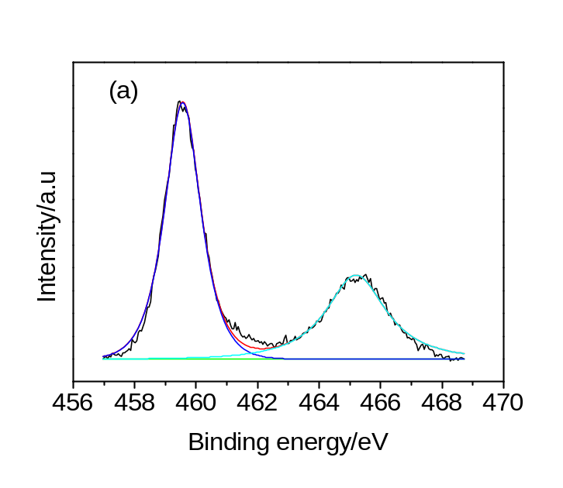
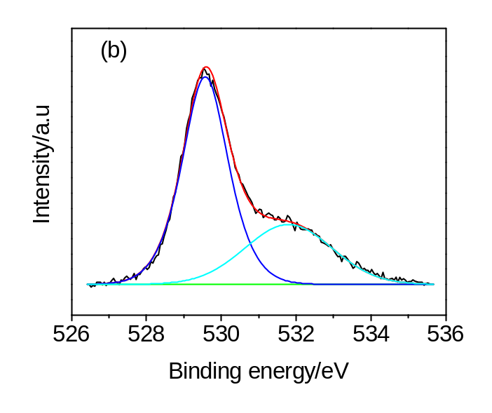
Figure S3 XPS spectra of Ti 2p (a) and O 1s (b) for N/Sn-TiO₂/In₂O₃.

